Sales Dashboard SQL Query
KPI Requirements:
1. Total Revenue:
Select sum(total_price) TotalRevenue from pizza_sales
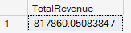
2. Average Order Value:
Select sum(total_price)/count(distinct order_id) AverageOrderValue from pizza_sales
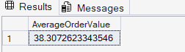
3. Total Pizzas Sold:
Select sum(quantity) TotalPizzasSold from pizza_sales
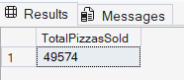
4. Total Orders:
Select count(distinct order_id) TotalOrders from pizza_sales
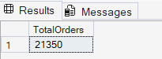
5. Average Pizzas Per Order:
Select cast(cast(sum(quantity) as decimal(10,2))/cast(count(distinct order_id) as decimal(10,2)) as decimal(10,2)) AveragePizzasPerOrder from pizza_sales
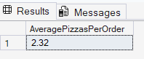

Chart Requirements:
1. Daily Trend:
select DateName(DW,order_date) OrderDay, count(distinct order_id) TotalOrders from pizza_sales group by DateName(DW,order_date)
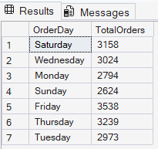
2. Hourly Trend:
select DATEPART(HOUR, order_time) OrderHour, count(distinct order_id) TotalOrders from pizza_sales group by DATEPART(HOUR, order_time) order by OrderHour
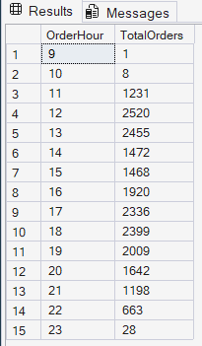
3. Percentage of Sales by Category:
Select distinct pizza_category,sum(total_price) TotalSales, (sum(total_price)*100/
(Select sum(total_price) from pizza_sales)) PercentSales
from pizza_sales
group by pizza_category
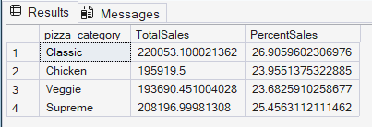

For January alone:
Select distinct pizza_category,sum(total_price) TotalSales, (sum(total_price)*100/
(Select sum(total_price) from pizza_sales where MONTH(order_date)=1)) PercentSales
from pizza_sales where MONTH(order_date)=1
group by pizza_category
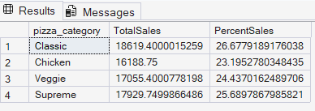
4. Percentage of Sales by Size:
select distinct pizza_size,sum(total_price)TotalSales,
sum(total_price)*100/(select sum(total_price) from pizza_sales) PercentSales
from pizza_sales
group by pizza_size
order by PercentSales desc
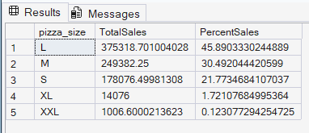
5. Total Pizzas Sold by Category:
select distinct pizza_category, sum(quantity) PizzasSold from pizza_sales group by pizza_category
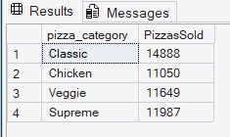
6. Top 5 Best Sellers:
select top 5 pizza_name, sum(quantity) TotalSold from pizza_sales group by pizza_name order by sum(quantity) desc
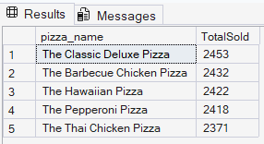
7. Bottom 5 worst Sellers:
select top 5 pizza_name, sum(quantity) TotalSold from pizza_sales group by pizza_name order by sum(quantity)
select top 5 pizza_name, sum(quantity) TotalSold from pizza_sales where month(order_date)=1 group by pizza_name order by sum(quantity) gives result for January alone
